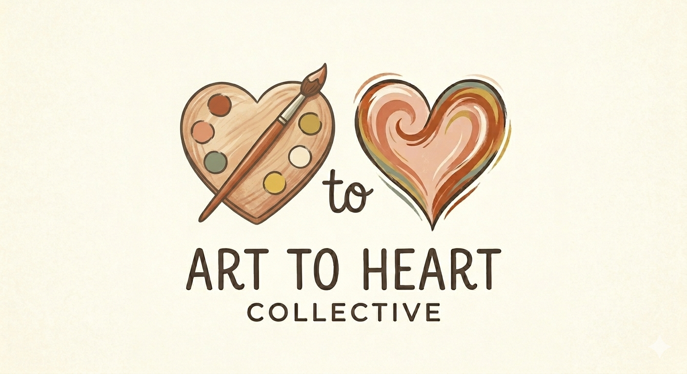

Artist Agreement
Simple, fair, and built on trust.

This agreement is between Art to Heart Collective (“A2H”) and the contributing artist named below. It is intended to be simple, respectful, and clear for both parties.

1. Artwork Submission
The artist agrees to submit original, handmade artwork in the agreed size (4” x 6” preferred size, or 5” x 7”) on watercolor or mixed media paper, card stock, or heavy paper that can handle the mail. All work must be the artist’s own original creation — no reproductions, prints, or copies of others’ work.

2. Usage Rights
The artist grants Art to Heart Collective the right to mail each submitted piece directly to a single recipient. A2H will not reproduce, resell, or use the artwork commercially in any other way. The artist retains all other rights to their work.

3. Artist Credit
Art to Heart Collective will include the artist’s first name, last initial, and medium with each card (e.g., “Watercolor · Maria S.”). If the artist prefers to remain anonymous, they may request this in writing.

4. Payment
A2H will pay the artist within 7 days of receiving and approving each piece. Payment will be made via the artist’s preferred method: Zelle, Venmo, or PayPal. Current rates are $5.00 for 4” x 6” (preferred size) and $7.00 for 5” x 7” pieces. Rates may be adjusted with 30 days’ written notice.

5. Quality & Content Standards
All artwork must be appropriate for recipients of all ages, backgrounds, and beliefs. Content that is offensive, graphic, or religious/political in nature will not be accepted. A2H reserves the right to decline any piece that does not meet quality or content standards. Declined pieces will be returned to the artist at A2H’s cost.

6. Relationship
Artists are independent contributors, not employees of Art to Heart Collective. There is no minimum submission requirement. Either party may end this arrangement at any time with written notice.

Artist Information

Artist Full Name

Preferred Payment Method & Username / Phone (Zelle, Venmo, or PayPal)

Mailing Address (for returned pieces if needed)

Email Address

Phone Number

Artist Signature Date

Email this completed form to:
hello@arttoheartcollective.com

Mail artwork in a standard greeting card size envelope to:
Tracy Myhalyk
2001 23rd Ave W
Bradenton, FL 34205

Or contact us to arrange for pickup in St Pete or the surrounding area
(727) 294-3178
arttoheartcollective.com

